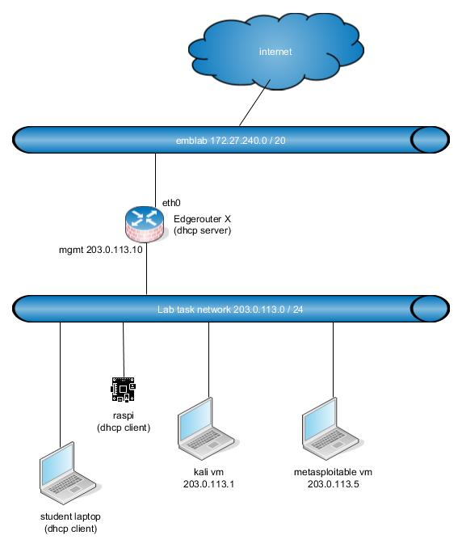
BEFORE DOING ANYTHING ELSE, CONFIGURE YOUR EDGEROUTER (see 1.1.1.0 Ubiquiti Edgerouter X setup for TUAS.pptx)!!

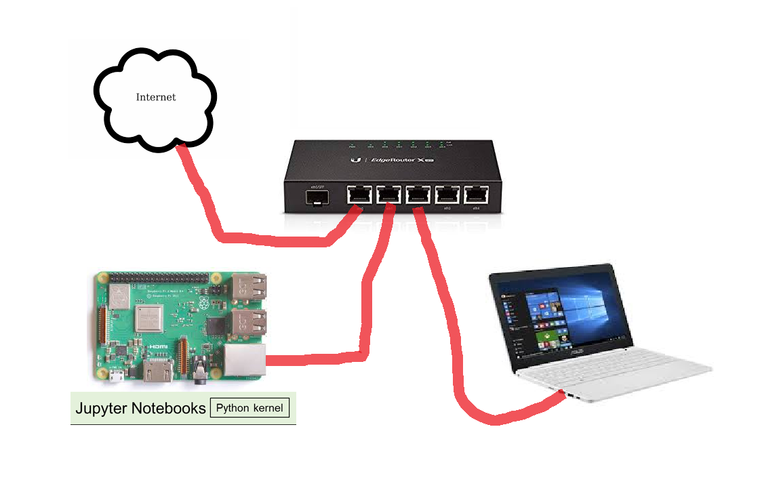
Lab – Set Up the IoT Security Lab Topology

Objectives
Part 1: Setup the Lab Environment
Part 2: Import the IoT Security Virtual Machines

Background / Scenario
Computing power and resources have increased tremendously over the last 10 years. A benefit of having multicore processors and large amounts of RAM is the ability to use virtualization. With virtualization, one or more virtual computers operate inside one physical computer. Virtual computers that run within physical computers are called virtual machines (VMs). VMs are often called guests, and physical computers are often called hosts. Anyone with a modern computer and operating system can run VMs.
In this lab, you will set up and explore the lab environment that will be used in this course. A VM is used for many of the labs in this course. The VM is created with Oracle VirtualBox and an Oracle virtual appliance (OVA) file. The OVA file contains a special version of Linux called Kali. Kali is a very popular Linux distribution that contains many tools that are used for assessing network security. VirtualBox allows you to run this version of Linux on a Mac or PC as a VM. You can use this VM to interact with other hosts on the lab network.
Note: Only use Kali tools on networks on which you are authorized to do so. Abuse of the Kali tools will be a violation of your ethical hacking agreement.

Required Resources
- Host computer with at least 4 GB of RAM and 15 GB of free disk space
- Oracle VirtualBox
- IoT Security Kali Linux OVA and Metasploitable OVA files
- Internet connection
- An Ethernet patch cable
- Setup the Lab Environment
Follow the directions of your instructor to build a lab topology similar to the one shown in the Topology section of this lab. Your topology may differ slightly. For example, several PCs and Raspberry Pi devices may be connected to the same switch. What is important is that you can identify your own target Raspberry Pi using PL-App launcher.
Note: For now, do not connect Raspberry Pi devices to the network.
ALSO DISCONNECT YOUR LAPTOP FROM ANY WIFI NETWORK. ONLY CONNECT YOUR LAPTOP VIA LAN CABLE TO EDGEROUTER AS INSTRUCTED.
- Download and Install Oracle VirtualBox.
      - Navigate to the Oracle VirtualBox downloads page.
      - Choose and download the appropriate installation file for your operating system.
      - After you have downloaded the VirtualBox installation file, run the installer and accept the default installation settings.
      - (Download the IoT Security VM file from emblab server ftp://172.27.0.40/IoT-Sec/) (outside emblab use Cisco originals in here: Kali OVA and Metasploitable OVA.
    - Connect the Network Topology
      - Set up router according to instruction slides “Ubiquiti Edgerouter X setup for IoT Security Course”.
- Import the IoT Security Virtual Machines
- Import the virtual machine appliance into VirtualBox.
You will open VirtualBox and import the IoT Security Kali VM.ova file to create a Kali virtual machine.
Note: The screen may look different depending on your version of VirtualBox.
      - Open VirtualBox. From the file menu, select: File > Import Appliance. Locate and select the Kali_IoTSec.ova file that you downloaded and click Next.
      - A new window will appear presenting the settings suggested in the OVA archive. Check the "Reinitialize the MAC address of all network cards" box at the bottom of the window. Leave all other settings as default. Click Import. (in Virtualbox version 6, the setting is Mac Address Policy: Generate new MAC addresses for all network adapters)
      - After the import is complete, VirtualBox will show the new Kali VM in its inventory. Your Kali Linux VM file name might be different than the graphic shown below.
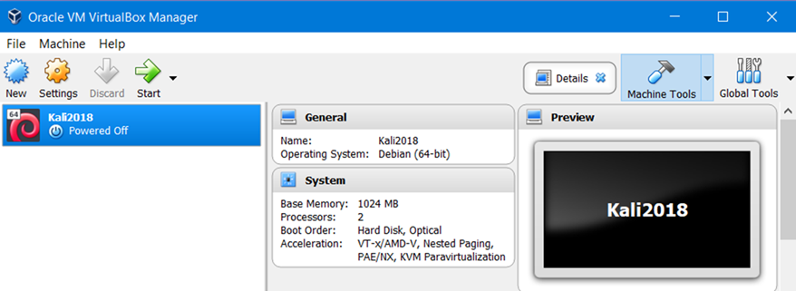
      - Repeat the import process for the Metasploitable VM.
- Verify Network Connectivity.
In this step, you will ensure that networking is configured between the VMs and the Raspberry Pi.
The host computer has been disconnected from the campus network and connected directly to network configured by Edgerouter. It is possible your Windows laptop does not immediately detect network change.
      - Return to the VirtualBox VM player window. Highlight the Kali VM in the list.
      - Click the green Start arrow in the menu bar. After a brief delay, you should see a new window open that displays a Username: field.
      - Enter the username of root and click Next to continue. Use toor for the password and click Sign in. If you have typed the username incorrectly for the Kali VM, click Cancel to input the correct username.
      - After Kali starts, you should see the desktop as shown below.
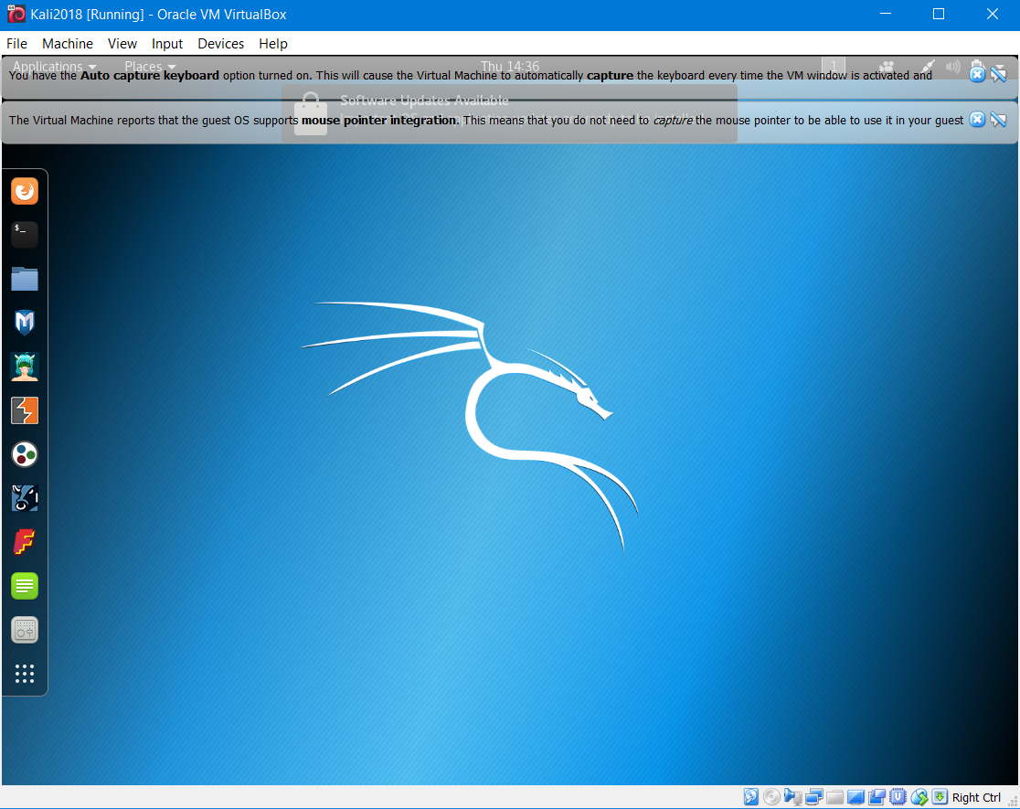
      - Click the Terminal icon in the desktop applications bar as shown in the figure
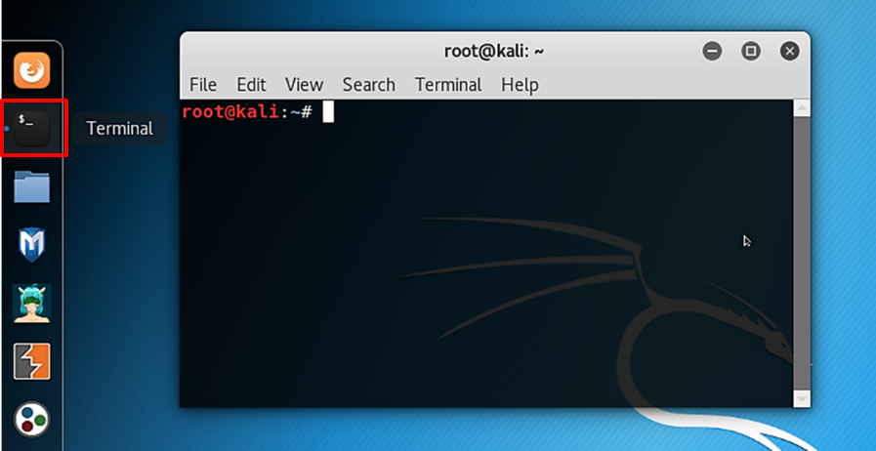
      - After the script executes, at the terminal prompt, type ifconfig
root@kali:~# ifconfig
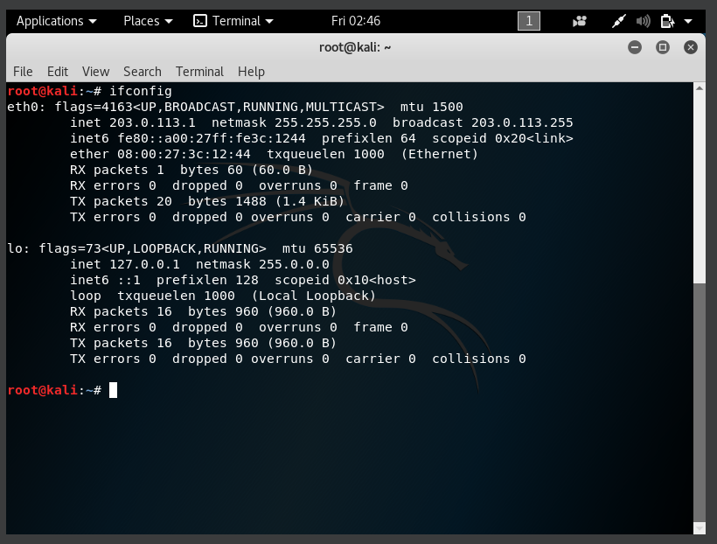
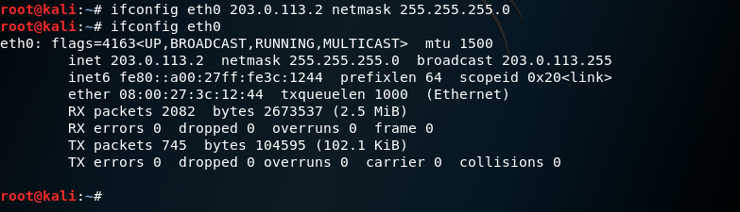
What IP address was assigned to the VM eth0 interface? The eth0 ip is 203.0.113.1

Then I change my ip, because my group college had the same ip as me

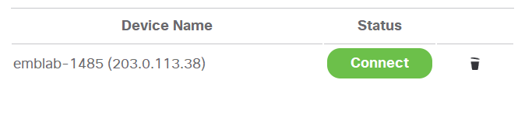
      - Minimize the VirtualBox window and open PL-App. Select the Available Devices tab. You should see your Raspberry Pi listed. Make note of the IP address of your Raspberry Pi.
IP address of the Raspberry Pi: The Raspberry PI IP is 203.0.113.38

Note: If PL-App is not showing the IP address of the Raspberry Pi, use the command fping at the terminal window to determine the IP address.
NOTE: keyboard layout is us by default, google how to change it to e.g. fi
root@kali:~# fping -a -r 0 -g 203.0.113.0/24
Warning: The use of fping can be considered as an attack. Please do not use this command on a production network.
      - Return to the VM. At a terminal prompt, ping the IP address of your Raspberry Pi. Use the -c 5 parameter to limit your ping to five echo requests. If everything is working properly, you should see five successful echo replies. You have now tested the connection between the Kali Linux virtual machine and the Raspberry Pi.
      - Now open the Firefox ESR browser from the Kali desktop applications bar. Its icon is just above the Terminal icon.
      - Type the IP address of the Raspberry Pi into the address bar and press Enter. You should see the Jupyter notebooks home page appear.
Note: Because the VM shares the same network adapter as the physical computer, you can access the Pi from either machine.
      - Start and log into the Metasploitable VM. Notice the displayed messages.
What is the login credential?
Like was said we used msfadmin for both, login and password
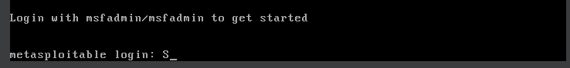
What is the IP address assigned to Metasploitable VM? What was the command used to determine the IP address?
203.0.113.5, the command used if ifconfi
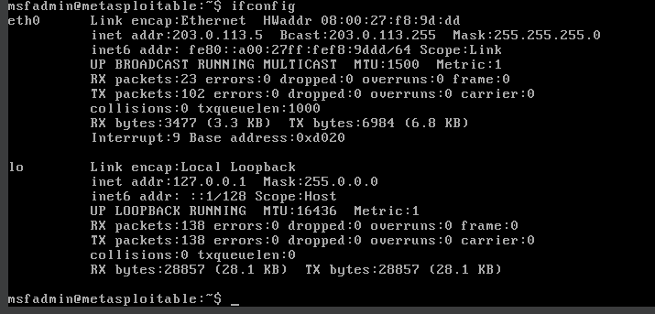
Note: To release the mouse from Metasploitable VM, press the right control key.
      - To verify network connectivity, you should be able to ping all the VMs and the Raspberry Pi.

Before going to step 3, demonstrate to teacher that both machines are working and the connection to raspi is ok.
- Shut down the VMs.
      - In the VirtualBox menu in the Kali VM window, select File > Close.
      - Click the Save the machine state radio button and click OK. The next time you start the virtual machine, you will be able to resume working in the operating system in its current state.
The other two options are:
• Send the shutdown signal: This option simulates safely shutting down a physical computer.
• Power off the machine: This option simulates an unsafe shutdown of a physical computer.
      - Repeat the shutdown process for the Metasploitable VM.

